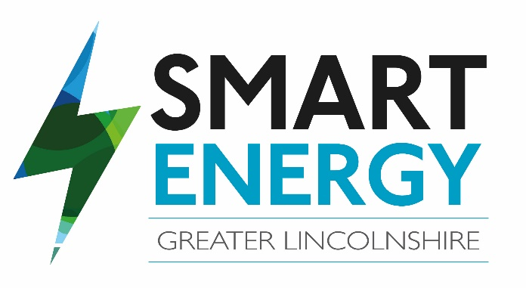
Smart Energy Greater Lincolnshire
Our business has benefited from the Smart Energy Greater Lincolnshire programme through grant funding and advice, helping us to become more energy efficient and reduce our carbon dioxide emissions.
Grant Received: £1857.45
It is part-funded by the European Regional Development Fund

